Putu Andika Eka Putra (pu an di)  
F11127807  
Electrical Engineering

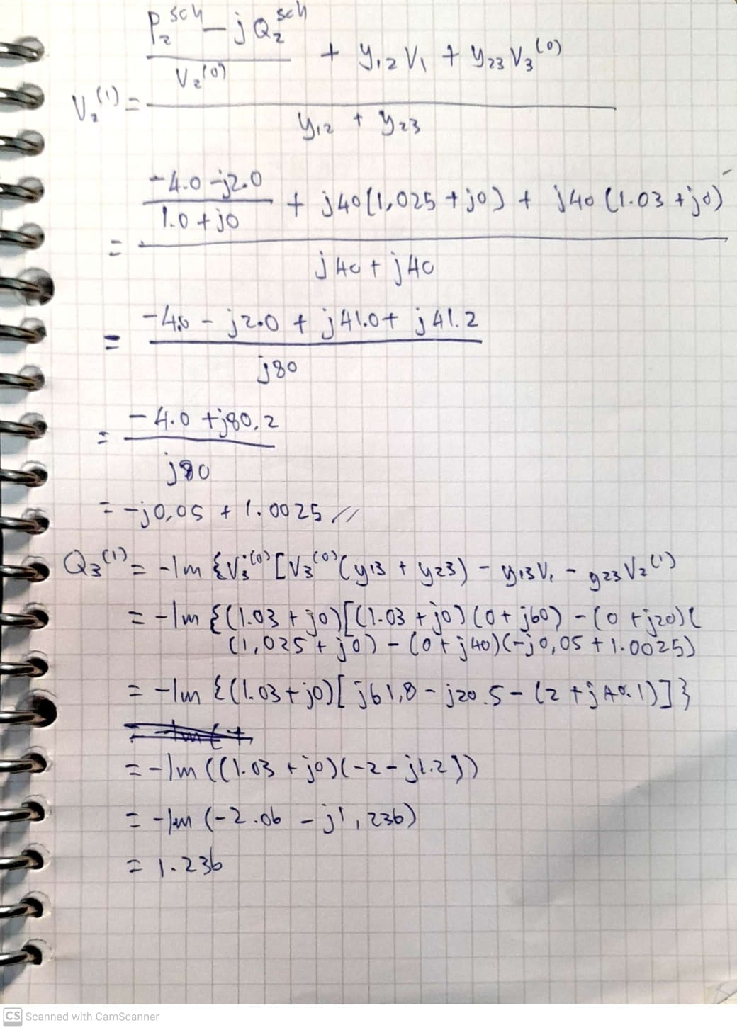**Power system and control: HW1**

1. 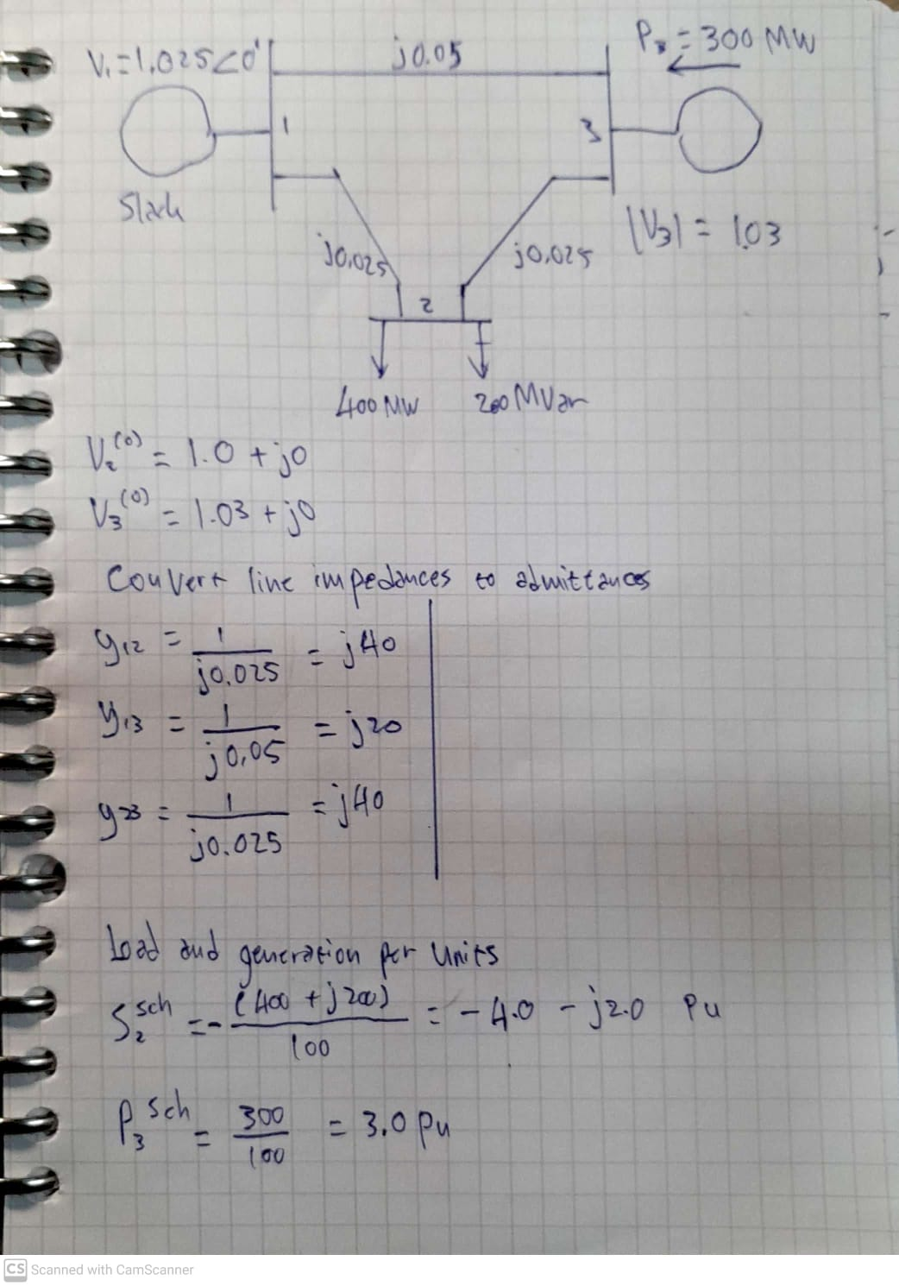

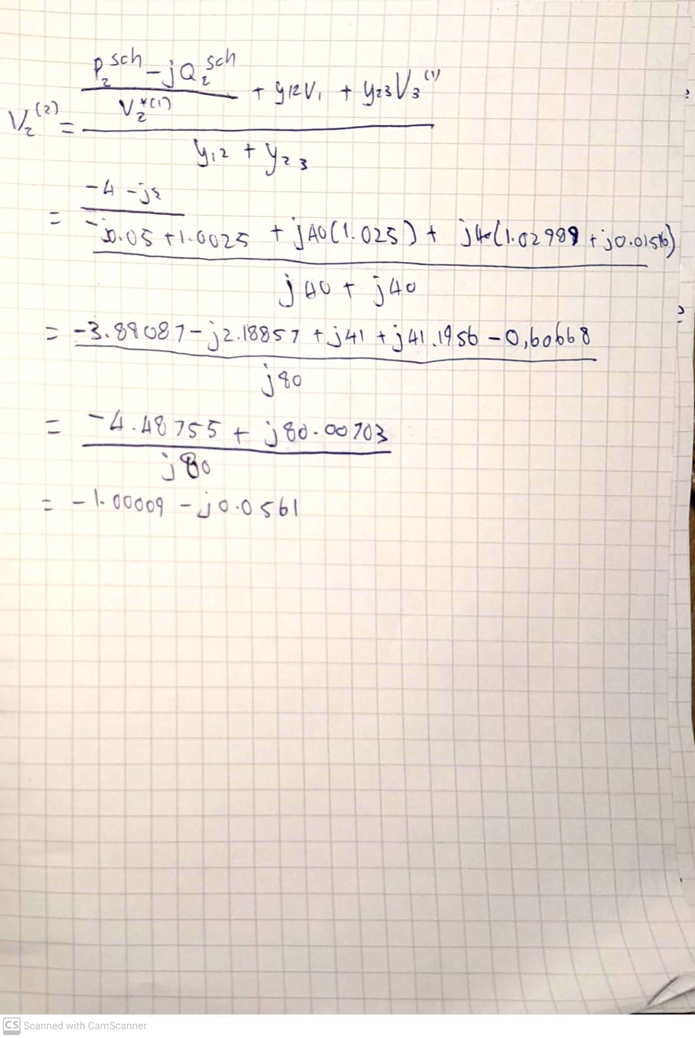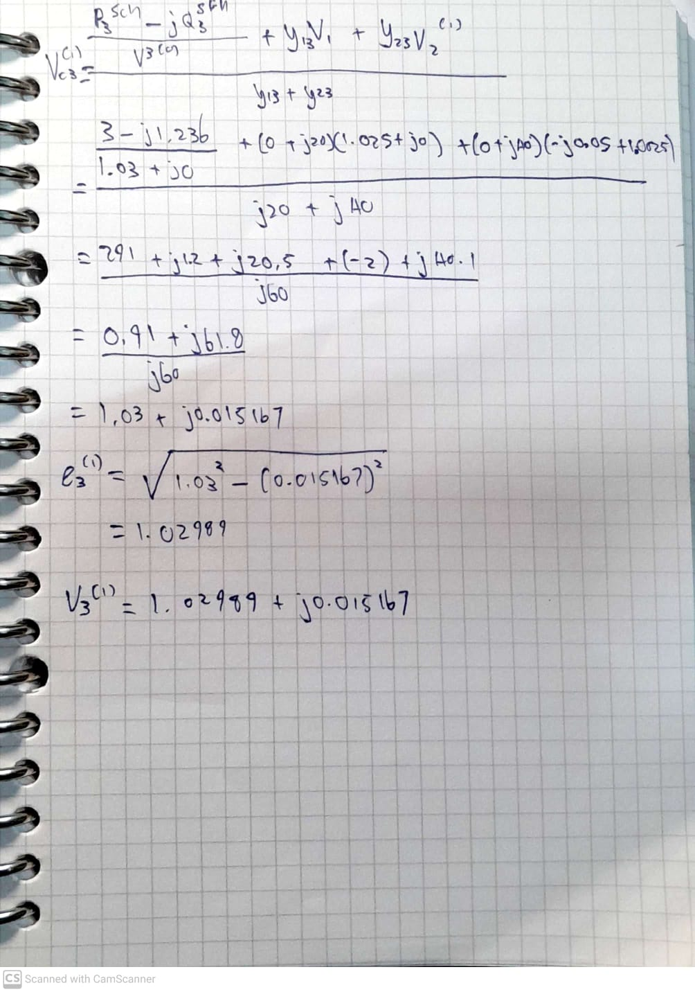

1. Not enough time

|  |  |
| --- | --- |
| andy.m |  |
| clear;  basemva = 100;  accuracy = 0.001;  accel = 1.6;  maxiter = 80;  busdata=[1 1 1.025 0 0 0 0 0 0 0 0  2 0 0 0 4 2 0 0 0 0 0  3 2 1.03 0 0 0 3 0 0 0 0];  linedata=[ 1 3 0 0.05 0 1  1 2 0 0.025 0 1  2 3 0 0.25 0 1];  import Lfybus.*;  import Lfgauss.*;  import Busout.*;  import Lineflow.*;  Lfybus  Lfgauss  Busout  Lineflow | >>andy  Power Flow Solution by Gauss-Seidel Method  Maximum Power Mismatch = 0.000408542  No. of Iterations = 18  Bus Voltage Angle ------Load------ ---Generation--- Injected  No. Mag. Degree MW Mvar MW Mvar Mvar    1 1.025 0.000 0.000 0.000 100.017 90.496 0.000  2 1.001 -2.100 400.000 200.000 0.000 0.000 0.000  3 1.030 1.368 0.000 0.000 300.000 136.941 0.000    Total 400.000 200.000 400.017 227.437 0.000  Line Flow and Losses  --Line-- Power at bus & line flow --Line loss-- Transformer  from to MW Mvar MVA MW Mvar tap    1 100.017 90.496 134.882  2 150.459 100.167 180.752 0.000 7.774  3 -50.423 -9.648 51.338 0.000 1.254    2 -400.000 -200.000 447.214  1 -150.459 -92.393 176.563 0.000 7.774  3 -249.592 -107.618 271.805 0.000 18.424    3 300.000 136.941 329.777  1 50.423 10.902 51.588 0.000 1.254  2 249.592 126.042 279.612 0.000 18.424    Total loss 0.000 27.452 |

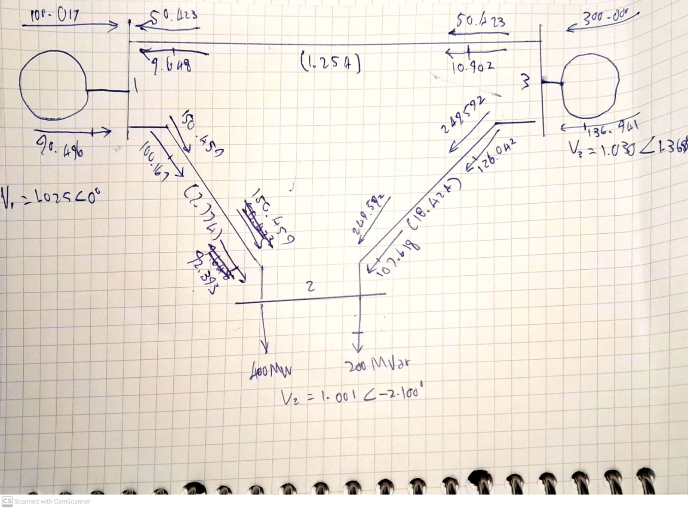

1. Explain your results.

With the given parameter, the program converged after 18 iterations. And I construct this power flow diagram. The total line loss is reaching 27.452 MVA.

According to the simulation both of my hand calculation for first and second iteration were wrong. And unfortunately, I still do not understand the cause.

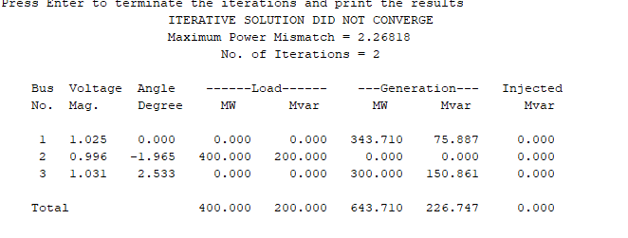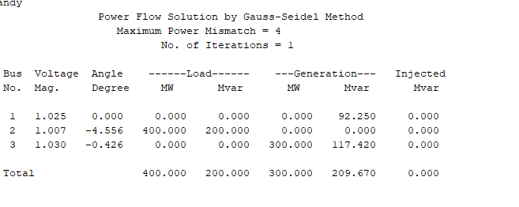it is possible that I made a rounding error or a simply miscalculation. I will keep trying to find the problem.